Meta Description:
Upgrade your style with the perfect cufflinks and pocket squares for any special event. Learn to match materials, colors, and folding techniques.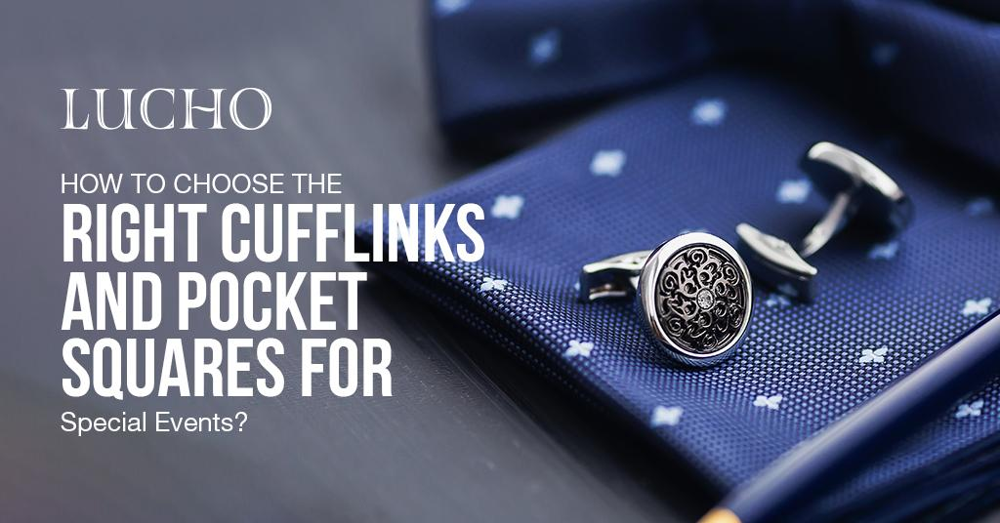

How to Choose the Right Cufflinks & Pocket Squares for Special Events? H1

The cufflinks, when combined with pocket squares, serve as suitable accessories for any occasion. Cufflinks and pocket squares improve the style quality of tops and suits and reflects essential details about your personality and attitude.
The process of choosing cufflinks together with pocket squares for a wedding or elegant dinner party creates both excitement and difficulty. Here are some factors you need to consider to make the right decision regarding the selection of cufflinks & pocket squares according to the nature of the event.

Start from the Basics H2
It is very necessary to know what cufflinks and pocket squares are before going into details on how to choose them. Cufflinks are formal accessories with the help of which the cuffs of dress shirts are fastened. They include the classic, buttonhole as well as decorative designs.
On the contrary, Pocket squares are small pieces of fabric that are placed in the front pocket.
Both of these accessories bring much-needed uniqueness to your personality and add a special color to your wardrobe.

Step 1: Know Your Occasion H2
Before selecting the accessories, first of all, know the type of event’s dress code. With regard to style and formality, many occasions will require different sorts of approaches and even protocols. Here is a brief guide that could be very helpful to you:

Black Tie Events H3
Opt for more luxurious and formal cufflinks and pocket squares. Do not use aluminum parts and any other ordinary metals that you would find in the market, instead, opt for more expensive metals such as gold or silver and patterns that look royal.

Business Formal H3
If the dress code is Business Formal, it is appropriate to avoid any extravagant and bright colors. As for accessories, cufflinks of silver or white gold for shirts with plain patterns for the pocket square.

Casual/Formal Functions H3
You have variable options in this area especially pertaining to the decorations for the venue. While the freedom of choice in color and patterns should be used, therefor you should not be too wild and remain at least somewhat classy.

Step 2: Choose Your Cufflinks H2
In the selection process of Cufflinks, you can consider factors like style, material and occasion.

Style and Material H3
Choosing the right style and material is critical as style reflects your personality, and the material reflects the level of the class in terms of success that you have achieved. Here are some popular options:
- Classic cufflinks: They are ideal to be worn on formal occasions. If you want to be on the safe side then look in the gold, silver, and platinum category for a classic look.
- Buttonhole Cufflinks: Ideal for shirts with buttonholes. You can choose the stainless steel if you want to have a rather sober material, or opt for gold-plated for a more luxurious material.
- Cufflinks Ornamental: Another reason where this could come in handy would be when you want to give a piece of jewelry that is personalized. These designs may include initials, family crest, or other figures, and they are perfect for making any outfit stand out.

Consider the Occasion H3
You can also select the Cufflinks according to the nature of the occasion, which is as follows:
- Formal Occasions: The cufflinks should be particularly selected to have precious stones or be uniquely designed.
- Business Settings: Opt for simple, elegant designs in silver or gold.
- Causal: Appropriately choose the color design to be more cheerful or playful but not flashy.

Step 3: Select Your Pocket Squares H2
In the selection process of pocket squares, you can consider factors like material & texture, pattern & color, and folding pattern.

Material and Texture H3
Finished products are pocket squares in various materials, and each fabric will produce a different texture and appearance.
- Silk: The most traditional material that is familiar to all, silk pocket squares have a buttery feel and excellent flow.
- Wool: It has a rougher surface as compared to the silk pocket squares, and they also provide warmth.
- Cotton: Due to their thin fabric and easy folding, cotton pocket squares are elegant and can be used in an event held during a warm season.

Pattern and Color H3
This largely depends on the pattern and color of the clothes you have decided to wear. Here are some tips that you can consider:
- Prints: Prints, be it polka dots, paisleys, etc. bring out the character in your dresser. Ensure that it is of good quality and complements with your suit and the shirt that you intend to wear underneath.
- Color: You let the color of the pocket square either be in harmony with the color of your tie or chosen to be a different color. Do not make it similar to the tie you choose, much less the shirt you plan to wear with it. Instead, try searching for colors that are opposite to each other.

Fold Your Pocket Square H3
It the manner in which Pocket Square are executed can change the whole appearance. Here are some popular folds:
- Presidential Fold: This is one of the simple but elegant ways of folding the cloth that is best suited for a formal event.
- Puff Fold: Adds volume and flair, ideal for more casual settings.
- One-point fold: This is one of the simplest types of folds that could be used in almost all occasions.

Step 4: Cufflinks & Pocket Squares H2
You would have to coordinate your cufflinks with your pocket squares. Here are some strategies you can follow to do that:

Harmonious Coloration H3
The selected colors should be friendly, and they should complement each other. Make sure your color combination should not be to an extent either aggressive or give off foil feelings. For instance, a pocket square in a navy blue shade of color is perfect for silver cufflinks.

Co-ordination Metals H3
In case your cufflinks are made of gold then make sure to complement it with a pocket square that has gold trimmed on it.

Sticking to a Theme H3
Using the set focal point, curves, stripes, etc., will create a harmonious pattern that you should adhere to in the selection of a theme.

Step 5: Consider Personal Style H2
Your accessories should always depict your personality. Here is how you could style it in different ways according to the nature of your personality:
- Adventurous Personality: If one has an adventurous personality, then one should embrace bright hues and designs.
- Country Chic: This style is also similar to the above but with minimal usage of color or the usage of pastel pink and blue and simple embroidery or floral prints.
- Exclusivities: Add features that make you stand out, be it a hue, a pattern or a clipart that you particularly love or has some meaning to you.

Step 6: Quality Matters H2
The high-quality cufflinks and pocket square will last long and also look better. Below are some tips to help in choosing good pieces to work with;
- Materials: Opt for durable materials like sterling silver, 18k gold, or high-quality silk.
- Craftsmanship: Choose designs with good quality and tiny features that demonstrate craftsmanship.
Choose prefers brands like Lucho, which is renowned in the market for its high quality and reliability.

Step 7: Experiment and Have Fun H2
Last but not least, you should not be afraid to be creative when selecting accessories. Fashion is the extension of your personality, and your clothes & accessories are the best way to enjoy your chosen looks and combinations.

Ending Note H3
Many men are always mistaken when it comes to choosing accessories like cufflinks and pocket squares to wear during occasions like weddings. If you understand the basics, know the occasion type, and do calculations for the type of style you want, you will be in a position to make the right choice.

Using the above tips, you are well-equipped to make a style statement whenever you are attending a special occasion. Check out the offered assortment of cufflinks and pocket squares at Lucho to accentuate your style perdition.
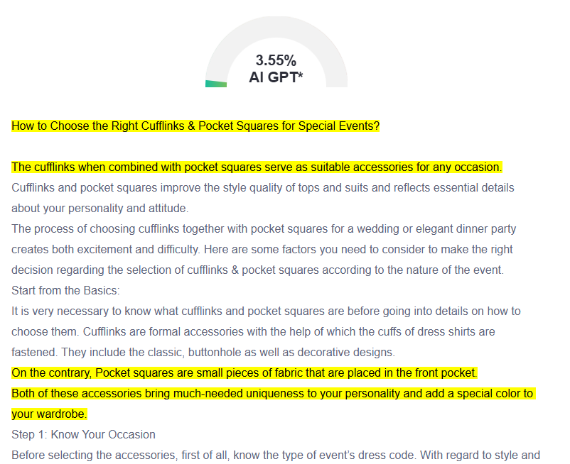
GMB

Creating the perfect ensemble for special events requires attention to detail, especially when it comes to accessories like cufflinks and pocket squares. Accessories serve as big style enhancers because they use minimal space yet remarkably emphasize personality. Choosing appropriate accessories plays a vital role in dressing for black-tie events and all other types of gatherings including business meetings together with casual social events. You can choose gold or silver cufflinks along with sophisticated designs when dressing for formal occasions. The business environment needs cufflinks made from silver or white gold together with pocket squares carrying refined patterns that match the overall appearance without overpowering it. The key to successful accessorizing lies in coordination. The color schemes and themes of your cufflink accessories should create matching combinations without duplication. You should always prioritize quality when buying ties from respected brands like Lucho. Your attention to style will shine through such details while creating memorable impressions. Remember that these accessories are an extension of your unique style. Whether you prefer bold patterns or subtle elegance, let your personality shine through a thoughtful selection of cufflinks and pocket squares that complement your attire and the occasion.

